

MOI GIRLS’ ELDORET 2025 PREDICTION
POSSIBLE KCSE EXAM
COMPUTER STUDIES
451/1
PAPER 1
TIME: 2½ HOURS

NAME……………………………………………………………………………………….
SCHOOL……………………………………………… SIGN………………………..
INDEX NO……………………………………………. ADM NO……………………

(Kenya Certificate of Secondary Education)

INSTRUCTION TO CANDIDATES
- Write your name and index number in the spaces provided above
- This paper consists of two sections A and B.
- Answer ALLquestions in section A.
- Answer question 16 and any other THREE questions from section B.
- All answers should be written in the spaces provided on the question paper.

For Examiners Use Only
Section | Questions | Candidates Score
A | 1-15
B | 16
 | 17
 | 18
 | 19
 | 20
 | TOTAL SCORE

QUESTIONS
- Name the parts labeled in the diagram below of a page layout properties [3 marks]

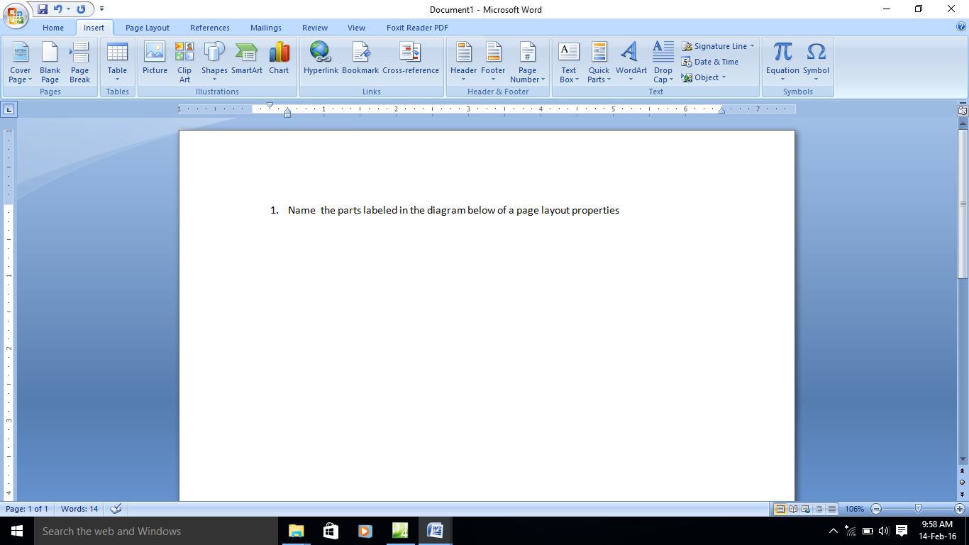

i ii iii
i- ___________________________________________________________________
ii- ___________________________________________________________________
Iii-___________________________________________________________________

- Explain briefly how an uninterruptible power supply (UPS) may help to protect a
computer system and its data. [1 mark]
__________________________________________________________________________________________________________________________________________________________________________________________________________________________________________
- How is data verification different from data validation? [1 mark]
__________________________________________________________________________________________________________________________________________________________________________________________________________________________________________
Give one example of data validation technique [1 mark]
______________________________________________________________________________

Give one example of data verification technique [1 mark]
______________________________________________________________________________

- What kind of program is normally contained in a ROM chip and Explain briefly the main
purpose of such a program. [2 marks]
__________________________________________________________________________________________________________________________________________________________________________________________________________________________________________

- Distinguish between system software and application software. [2 mark]
…………………………………………………………………………………………………………
…………………………………………………………………………………………………………
…………………………………………………………………………………………………………

- Give the similarities between optical mark readers and optical character readers. [2 marks]
…………………………………………………………………………………………………………
…………………………………………………………………………………………………………
…………………………………………………………………………………………………………
…………………………………………………………………………………………………………

- In word processing, distinguish between text insertion and overtyping. [2 marks]
…………………………………………………………………………………………………………
…………………………………………………………………………………………………………
…………………………………………………………………………………………………………

- Explain, using examples where appropriate, the meaning of these computer terms.
(i) interrupt [2 Marks]
…………………………………………………………………………………………………………
…………………………………………………………………………………………………………
(ii) buffer [2 Marks]
…………………………………………………………………………………………………………
…………………………………………………………………………………………………………

- Explain the following spreadsheet concepts:
(i) Automatic Recalculation. [1 mark]
…………………………………………………………………………………………………………
…………………………………………………………………………………………………………
(ii)What if analysis [1 mark]
…………………………………………………………………………………………………………
…………………………………………………………………………………………………………

- Explain briefly why the advancement of computer technology has caused environmental hazards. [2 marks]
…………………………………………………………………………………………………………
…………………………………………………………………………………………………………
…………………………………………………………………………………………………………
(i)What is telecommuting? [1 mark]
…………………………………………………………………………………………………………
…………………………………………………………………………………………………………
(ii)State four benefits of telecommuting. [2 marks]
…………………………………………………………………………………………………………
…………………………………………………………………………………………………………
…………………………………………………………………………………………………………
…………………………………………………………………………………………………………

(ii)How is e-commerce different from e-business? [1 mark]
…………………………………………………………………………………………………………
…………………………………………………………………………………………………………
…………………………………………………………………………………………………………

- (i)What is a coprocessor? [1 mark]
…………………………………………………………………………………………………………
…………………………………………………………………………………………………………

(ii)How does parallel processing work? [1 mark]
…………………………………………………………………………………………………………
…………………………………………………………………………………………………………
…………………………………………………………………………………………………………

(iii)What is pipelining? [1 mark]
…………………………………………………………………………………………………………
…………………………………………………………………………………………………………

- (i)What is a driver program? [1 mark]
…………………………………………………………………………………………………………
…………………………………………………………………………………………………………

- (ii). Give one example of hardware device that may serve more than one purpose (e.g., input and output). [2 marks]
…………………………………………………………………………………………………………
- (i)How is a patent different from a trademark? [2 marks]
…………………………………………………………………………………………………………
…………………………………………………………………………………………………………
…………………………………………………………………………………………………………

(ii)What is the difference between unauthorized access and unauthorized use? [2 marks]
…………………………………………………………………………………………………………
…………………………………………………………………………………………………………
…………………………………………………………………………………………………………

- (i)What is a workstation? [¹/₂ mark]
…………………………………………………………………………………………………………
…………………………………………………………………………………………………………

(ii)What is a server? [¹/₂ mark]
…………………………………………………………………………………………………………
…………………………………………………………………………………………………………

SECTION B
Answer question 16 (compulsory) and any other three questions from this section
- (a) Explain the three control structures in programming [3 Marks]
(b)State and describe three types of error can occur in programming [3 Marks]
(c)(i) State two differences between a compiler and an interpreter [2 marks]
(ii)Give one advantage of compliers over interpreters [1 mark]
(iii)Give one advantage of interpreters over compliers [1 mark]
(d) Draw the corresponding flowchart for the pseudo code below. [4 marks]
Assign 0 to A,
Repeat adding 1 to A,
Until A is greater than or equal to 5,
Print A.

- (a) How is peer-to-peer network different from client/server network, considering how
programs, data and information are stored? [2 marks]
(b) (i) Give three advantages of optical fibers over twisted-pair wires and coaxial cables.
[3 marks]
(ii) Suggest two disadvantages of optical fibers. [1 mark]
(c) (i)Compare asynchronous and synchronous transmission. [1 mark]
asynchronous | synchronous

(ii) Give one disadvantage of the c(i) above [1 mark]
asynchronous | synchronous

(d) (i)Compare the following Ring ,star and bus network topologies. [1 ½ marks]

Bus NetWork | Ring NetWork | Star Network

(ii)Give one disadvantage of each [1 ½ marks]
Bus NetWork | Ring NetWork | Star Network

(iii)Draw a diagram t represent the ring ,star and bus topologies [1 ½ marks]
Bus NetWork | Ring NetWork | Star Network
(e) (i) Explain the term upload [¹/₂ mark]
(ii)If a 56K modem is operating at full speed, how long does it take to download a 1-MBfile? [2 marks]

18. (a).Describe the role of the systems analyst. [2 marks]
(b).Describe 2 techniques used by the systems analyst in requirements specification.[2 marks]
(b).In the software development process, what happens at the analysis stage? [1 Mark]
(c) Describe fully what is meant by the term top-down design? [3 Marks]
(d) The process of developing such software is an iterative process. What does iterative mean?
[1 Mark]
(e)(i) What are CASE tools? [1 Mark]
(ii)What is the purpose of CASE tools? [1 Mark]
(iii) What does CASE stand for? [1 Mark]
(f) Identify ant two activities within the design stage of the software development process
[3 Marks]

19 (a).Describe four functions of a single user operating system. [4 Marks]
(b) Explain the need for an operating system to have a command language interpreter. [1 Mark]
(c) Give 4 examples of the many processes which can be initiated by a user and which are then
carried out by the operating system. [4 Marks]
(d) What happens if a command entered by the user is not recognized by the operating system?
[1 Mark]
(e)Describe an advantage and a disadvantage to storing the operating system in RAM rather than in
ROM? [2 Marks]
(g) Describe three features that a networkoperatingsystem must have that a single user operating
system does not need. [3 Marks]

20. (a) Explain two reasons why computers use the binary system? [2 Marks]
(b)What is meant by the term word in the phrase 16-bit word computer? [1 Mark]
(c) What is the decimal value of the largest integer that can be represented by a byte in a
computer which deals only with positive numbers? [1 Mark]
(d )What does the acronym ASCII stand for and what is ASCII? [2 Marks]
(e) Complete the following table and note that no marks will be awarded for answers with missing or unclear working. [6 Marks]
Bin | Dec | Hex
 | 45
 |  | B6
11001

